Hello and thank you for registering yourself or a family member/spouse to help as a volunteer coach or assistant coach or team manager in the Horsham Soccer program. Anyone that will be on the sidelines during a game or assisting in practices must have these clearances.

The new season is coming quickly, and your background clearances need to be updated in gotsport if they are not current. We are very strict on the safety of our children in our club. We need to ensure all volunteers have completed our risk management background check before they step foot on the field with children. The process is very straight forward and can be found on our website and below.

Should you already have clearances from other sports or work please reply to us and we can discuss but we need you to still be processed on the below website as part of our risk management coverage.

ALL GOTSPORT PROCESSES NEED TO BE DONE ON A LAPTOP OR PC-NOT A PHONE.

All coaches are required to obtain and submit clearances which include the following:
- Pennsylvania Child Abuse History Clearance;
- Pennsylvania State Police Criminal Record Check; and
- Federal Bureau of Investigation Criminal Background Check (on exception for residents that have not been in PA for more than 10 years.)

Information regarding the Pennsylvania Child Abuse History Clearance is contained below, as well as a link to additional information regarding the Pennsylvania State Police Criminal Record Check and the Federal Bureau of Investigation Criminal Background Check.

1) The Pennsylvania Child Abuse History Clearance can be submitted for online through the Child Welfare Information Solution (CWIS) self-service portal: Click here to access CWIS Self Portal (Volunteer position requests are free on the site) Submitting an application online allows individual applicants to receive their results through an automated system that will notify the applicant once their results have been processed. Applicants will be able to view, download, and print their results online.

2) To complete the State Police Background Check. Applicants can go to the Pennsylvania Access To Criminal History website and apply for their criminal record check online with the Pennsylvania State Police at: https://epatch.state.pa.us/Home.jsp (Make sure you select the Volunteers Only link)

3) FEDERAL BUREAU OF INVESTIGATION (FBI) CRIMINAL BACKGROUND CHECK INSTRUCTIONS
The Pennsylvania Department of Human Services is utilizing IdentoGo to process fingerprint-based FBI criminal background checks. The fingerprint based background check is a multiple step process. For more information and to begin the registration process, go to https://www.identogo.com/. If your role/position is unpaid, you will want to use our volunteer service code, 1KG6ZJ

For PA residents who have lived in the state of PA for 10 years or MORE:
- The Pennsylvania Child Abuse History Clearance
- Pennsylvania State Police Criminal Record Check
- Signed ACT 153 Volunteer Affidavit

For PA residents who have lived in PA for LESS than 10 years:
- Pennsylvania Child Abuse History Clearance
- Pennsylvania State Police Criminal Record Check
- Federal Bureau of Investigation Criminal Background Check

Once you have all of these saved electronically, you will need to upload them into gotsport.

www.system.gotsport.com

You will need to login with your user name and password. If you were a coach last year, you do have an account. Click forgot password if you do not remember your password.

Once you see your profile, there is a listing of USYS requirements. The PA child welfare(child abuse), FBI Fingerprint or Affidavit, and PA State police Criminal History are the ones that will need loaded. If they say Required, you must upload a current copy or you will not be able to be on the sidelines with the children this season.

Safe Sport, Heads Up and EPYSA Risk Management will also be required as a coaching by EPYSA. These will expire 1 year after you completed them, so if you completed them last year, they may have already expired and you will need to upload new ones.

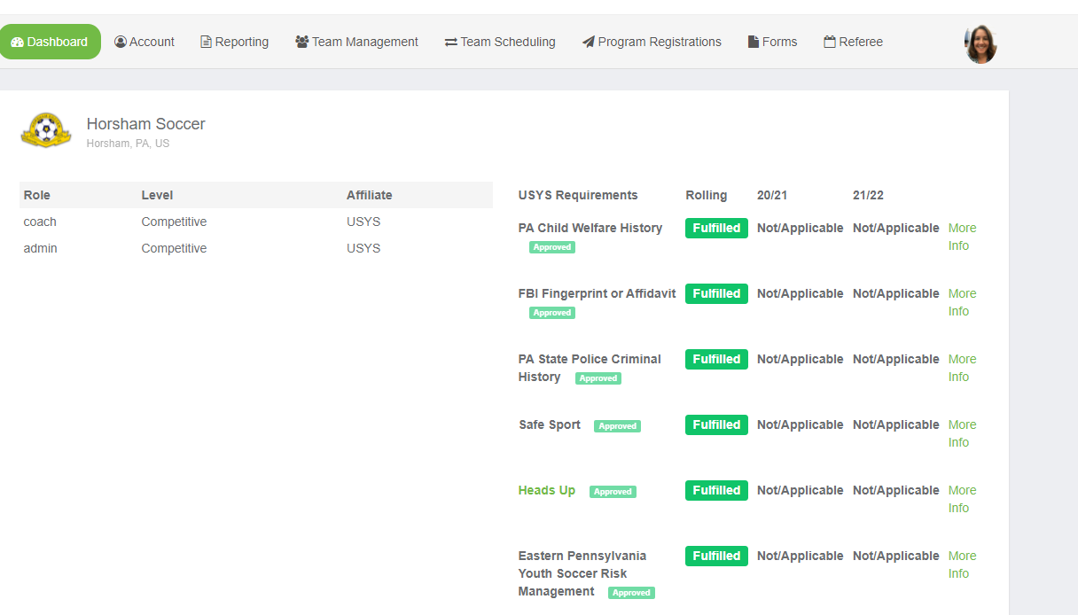

Next to each requirement, click More info and you will see this page. Click on Submit New Report.

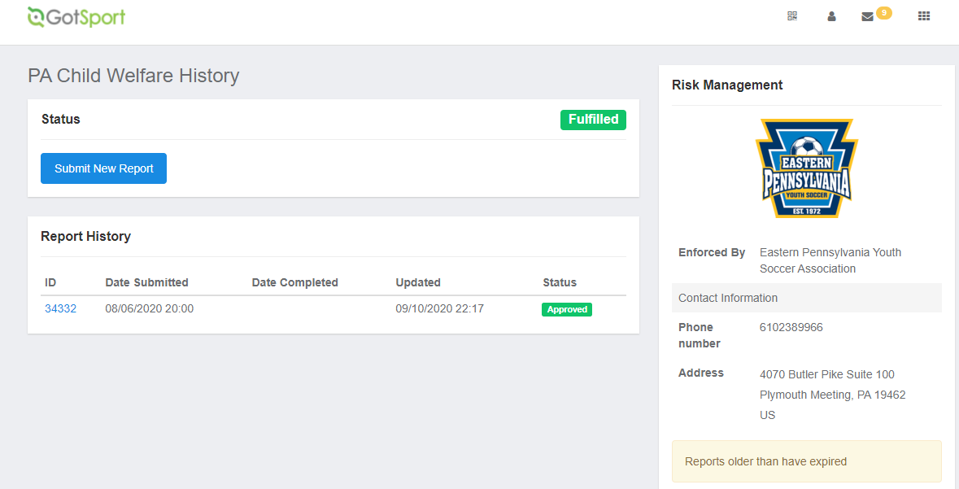

Fill in the required information then attach your report. Once they are reviewed by EPYSA risk management, they will be approved. This may take a few days.

4.) Heads up concussion course: annual recertification.

When you have to create an account, there is not a code for Horsham Soccer. Follow the below picture for the correct group. MAKE SURE YOU ARE SIGNED INTO THE CDC TRAIN SITE before you start this class or it will not allow you to take the post test and get the certification. https://cdc.train.org/cdctrain/login

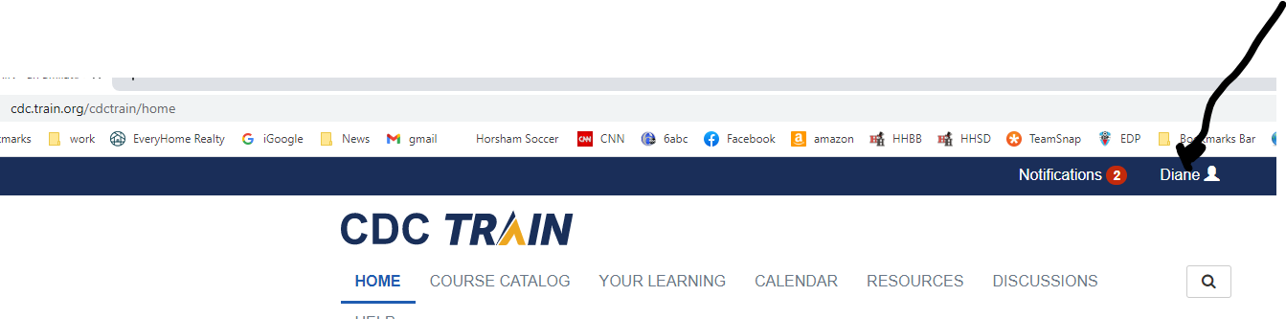
Make sure you see your name in the right hand corner before you start.
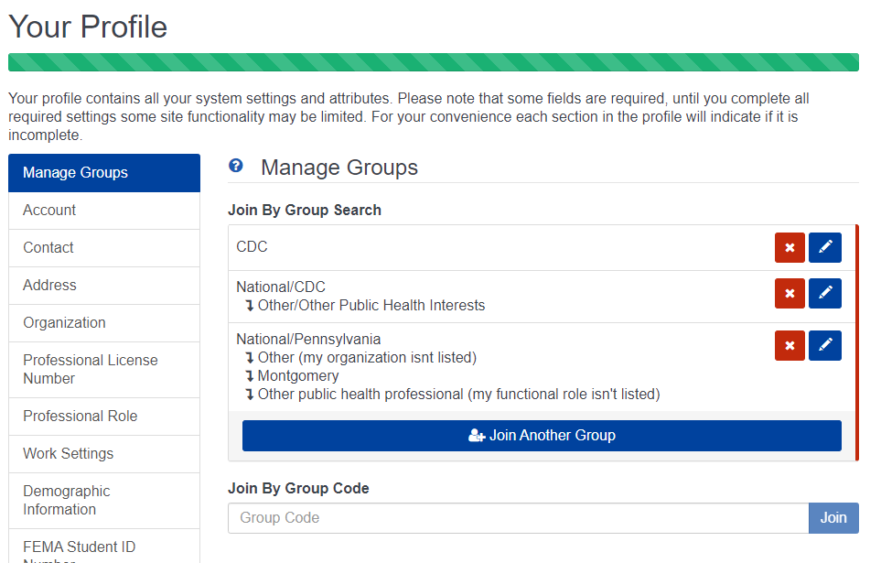
The class that you want is Heads Up to Youth Sports: Online Training for Coaches. The certificate for this is what is uploaded to Heads Up in EPYSA.

5.) Safesport: annual recertification

When you click on more information on the dashboard for safe sport, copy and paste that access code before you, click start course. You will need that to register.

If you have any questions or need assistance in any way with this task, please feel free to email dnelson@horshamsoccer.com.

Please review these details and complete the required steps for our risk management process. Once you have completed the process online please email dnelson@horshamsoccer.com to confirm it is done. We need to confirm this is completed for all coaches and assistant coaches to begin practices/games with your team.

Thank you again for volunteering and for taking the few minutes to address this very important topic for our club and our children. Without your time and energy, we would not be able to provide outstanding programs at Horsham Soccer.

